**Ecommerce Android App Documentation**



By,

Tharun Tej Tammineni

**TITLE: Product Search on different online shopping portals.**

**Instructions to run the Project:**

When the application is loaded it will display the products based on the preferences, if exists, else it will load the products based on default search term and price.

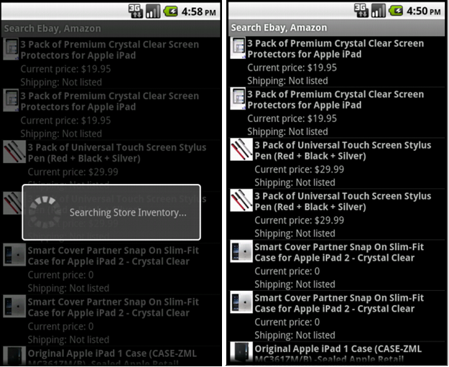

Now, when you click the menu button, you will see two menu options namely search term and preferences. When you click on search terms a dialog box will be popped up with two edit texts which will have the options for the user to enter key word (for the product to be searched) and max price (of the product to be searched).

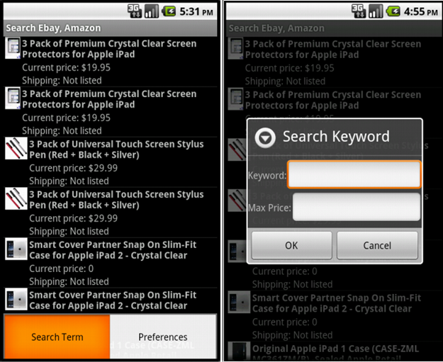

When you click Ok, the application will search on eBay and Amazon for the keyword (product) entered by the user and will get the results from eBay and Amazon which in turn will be merged by the application and displayed onto the screen.

When you click any of the products from the list displayed a pop up screen will appear which will display some details of the product along with a link to the original listing on the respective site (Amazon, eBay).

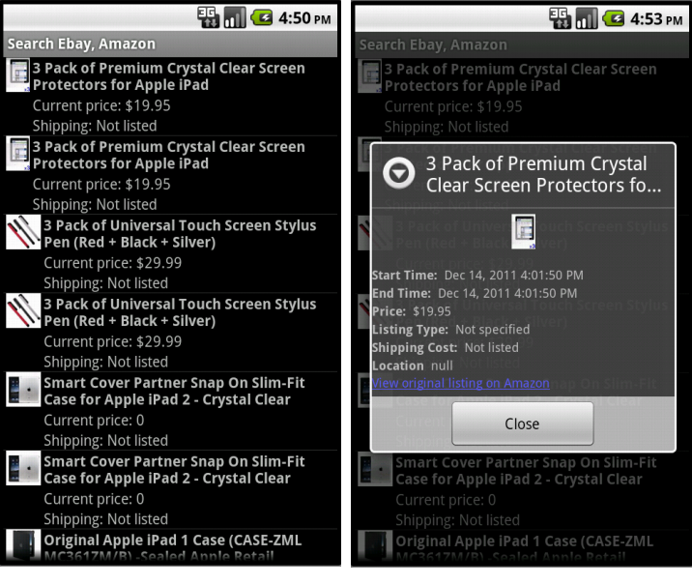

When you click on the link in the product pop up screen, the user will be directed to the respective shopping site (Amazon, eBay).Here the screen example shows the mobile version of ebay site

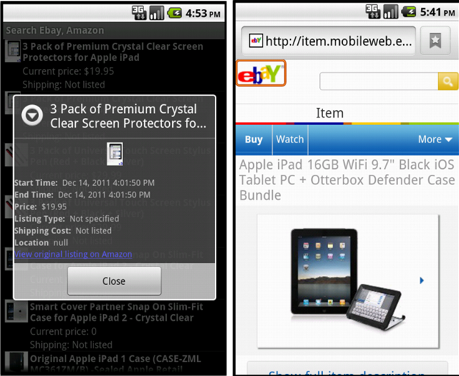

We have a feature where user can set preference for his search term (product) and the maximum price for that product. When the application is restarted the application will automatically take the keyword (product) and maximum price from the values stored in the preferences and search for the products on Amazon and eBay and display the search results automatically.

